**Daily Scrum or Standup Meeting**

Team name: 5th Element

Scrum Master: Leonardo Craven

Date: October 29, 2021

| **Team Member** | **What did you do since the last scrum?** | **What do you plan to do before the next scrum?** | **What obstacles do you have?** |
| --- | --- | --- | --- |
| Leo | Updated archived tournament page to show only tournaments player signed up for if player, all tournaments if manager | Work on tournament scorecard page | None |
| Gavin | Nothing | Work on tournament leaderboard page | None |
| Andrew | Finished sponsor existing tournaments page | Brainstorm ideas on how to make the website more visually appealing | Nothing |
| Brock | Nothing | Work on registered tournaments page | Midterms (until Monday) |

# Burndown

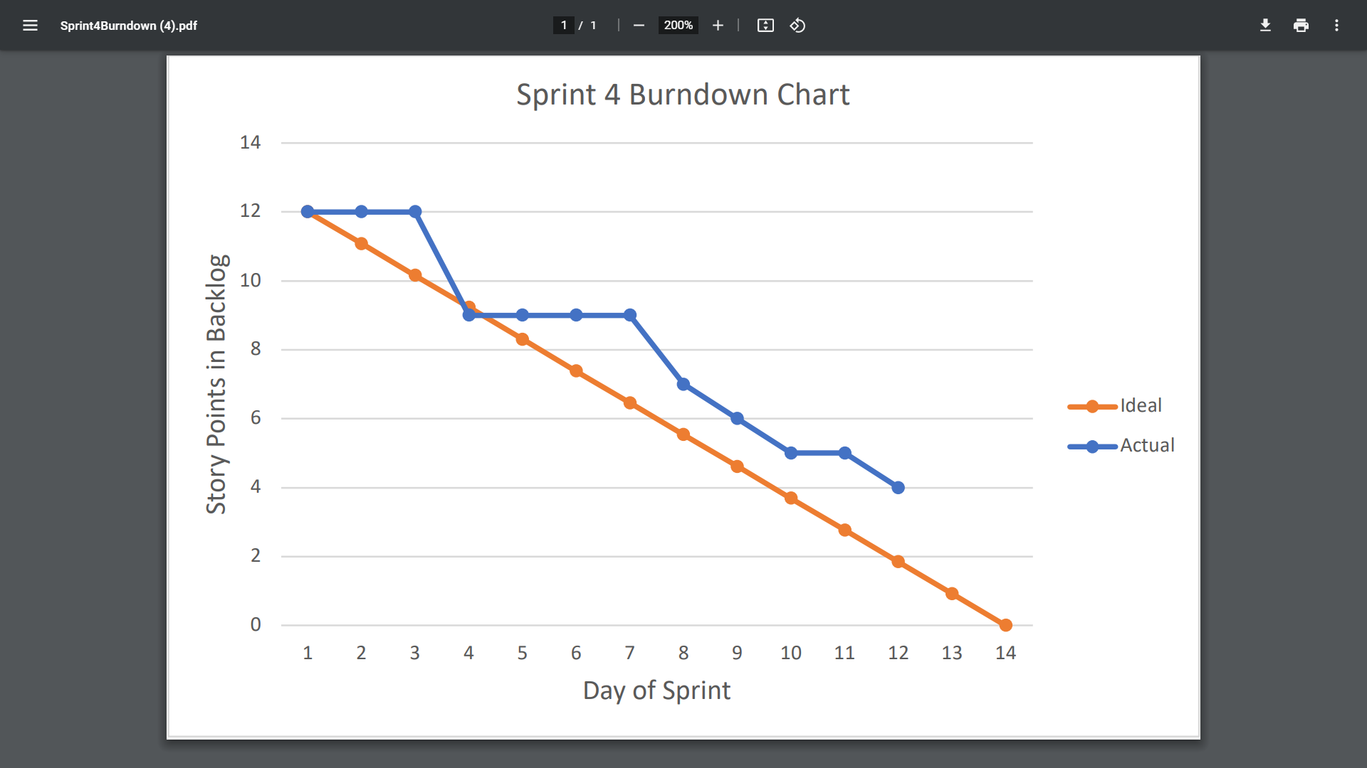

# Screenshot of you project board

